Grade 1/2 Supply List 2019-2020
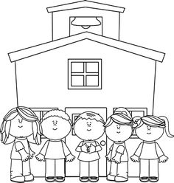

The following is a list of supplies:
1 book bag (labeled with name!)
1 pair of indoor sneakers to be kept at school (suitable for Phys. Ed.)
2 boxes of tissue (ie: Kleenex)
1 box of large or small Ziploc bags
1 box of Crayola broad line markers
An extra set of bagged and labeled clothes (in case of accidents!)
$40 student fee (cheques can be made payable to Park Street School)

We are excited to be teaching your children in the fall! We will be taking a team teaching approach with the grade 1 and 2 classes next year. This will provide extra support for your children as we can better meet their needs. We look forward to meeting you in September and hope you have a wonderful summer!
Shauna Kelly and Erin Gallagher

